**Robotic Process Automation Closing Protocols Document**

**Department:** Tax

**Process Name:** Tax R&D Work Order Lookup

**Process Overview:** This process accesses requested work orders and saves them as pdfs to a shared file, which are then used to calculate the Sec. 174 R&D deduction and the Sec. 41 R&D tax credit for Ameren's income tax return.

**Roles**

**Process Owner:** Debbie Schneider

**Process Designer:** Kevin Schroeder

**Configuration Specialist:** Kevin Schroeder

**Advanced Configuration Specialist:** Yajas Dwivedi

**Department Sponsor:** Brenda Menke

**How to Run the Wizard**

This is an unassisted process which will be kicked off by a user manually through Leo Player. The user will need to install Leo Player on his/her machine to kick this process off.

Person(s) approved to kick-off is/are: Kevin Schroeder, Felicia Harris

Note: User running this process needs to have the proper rights beforehand in order to access Leo Player and the wizard.

1. Open Leo player.

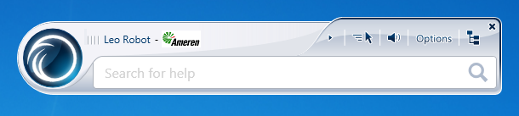

1. Click on the hierarchy icon situated on the top right corner of the Leo player.

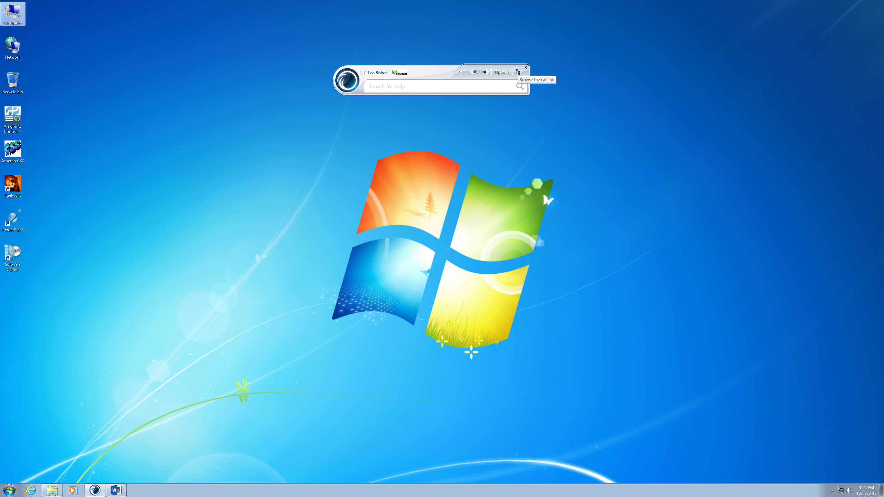

1. Browse the catalog and select the wizard "Run Work Order Lookup from Leo Player "

It's located in **Tax\Work Order Lookup\Run Work Order Lookup from Leo Player.**

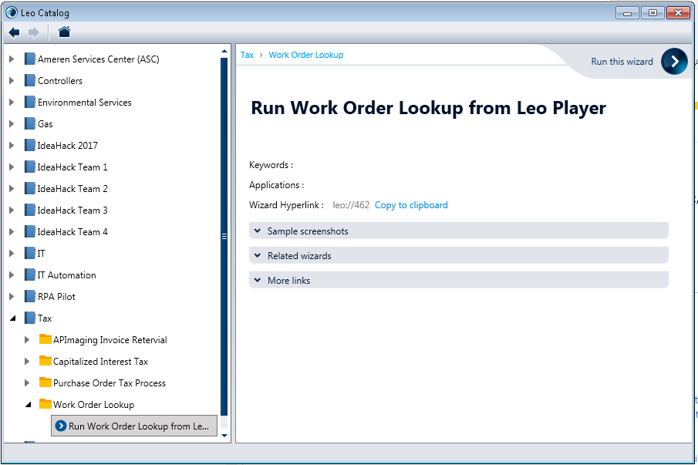

1. Click on the Run this wizard icon (with **>** sign) on the top right corner of the screen.
2. Now click on "Do it" button to run the wizard.

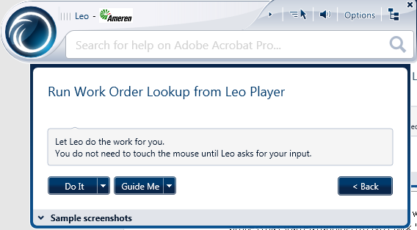

Warning:Sometimes Leo player works slow. Be patient to see the confirmation that your process has started running. DO NOT click 'Do It' multiple times.

**Access Requirements**

Note: This wizard requires Python to be installed on the machine the wizard is going to be running on for email functionality. Details on how this is achieved can be found in the [Handover Document](http://sharepoint1/sites/RPA/Department%20Docs/Tax%20Department/Tax%20R%20and%20D%20Work%20Order%20Lookup/RPA%20Handover%20Document%20-%20Tax%20R%20and%20D%20Work%20Order%20Lookup.docx).

(http://sharepoint1/sites/RPA/Department%20Docs/Tax%20Department/Work%20Order%20Lookup/RPA%20Handover%20Document%20-%20W.O.%20Process.docx)

The process requires access to the following applications:

1. PowerPlant
2. Adobe PDF*
3. Notepad

*Adobe PDF is only used to save the report.

**Configuration Timeline**

**Total time taken to configure process: 16 business hours**

November 10 – Process is put forward as a candidate for automation, Kevin Schroeder begins initial configuration.

November 16 – Process is handed over to Advanced Configuration Specialist, configuration continues with periodic meetings of ACS and Kevin Schroeder.

November 18 – Configuration complete.

November 23 – Configuration review with Mary K.

November 28 – Automation is deployed on QA bot for testing.

**Testing Details**

* Each step of the process has been tested upwards of sixty times by the ACS on his machine.
* Each step of the process has been tested upwards of sixty times by the configuration specialist on his machine.
* The output of the wizard, the pdf file of the work order, has been validated to be correct by Kevin Schroeder.
* The wizard has been deployed on the QA bot and has run to completion successfully multiple times (15+) without any human intervention.

Note: Comprehensive testing has been done to ensure error scenarios have been taken into account – However, unanticipated errors will cause the process to stall/finish unsuccessfully. In case of failure/unsuccessful completion, an email containing the date and time stamp indicating when the process crashed and a copy of the error along with the path to the folder with images of the steps that occurred when the wizard crashed. The Error logs can be found at: O:\Tax\RPA\Work Order Lookup\Error Log

**Efficiency/Time Savings**

The process takes an average of 40 hours annually and affects 3 employees. The automation is able to complete a single WO lookup in under a minute. Annual savings of approximately 40 hours are expected. Multiple WOs may be added to the input file. The user will get a success notification email with the path to the folder where the WOs have been saved.

(O:\Tax\RPA\Work Order Lookup)

The automation also enables the department to look up WOs for other projects, which otherwise is not done. This gives the department the ability to look into projects with more detail.

**Inputs and Outputs**

Inputs to the process are:

1. Manual trigger from Kevin Schroeder or Felicia Harris through Leo Player to initiate the wizard.
2. Text file containing the Work Orders to be processed (O:\Tax\RPA\Work Order Lookup\Work Order Numbers.txt).

Outputs from the process are:

1. Folder of same name as the Work Order - containing the Work Order report in pdf format.
2. An exception file containing WOs that couldn't be found (O:\Tax\RPA\Work Order Lookup\Work Order Exceptions.txt)
3. Success email indicating the process has completed successfully.

The above files may be found at O:\Tax\RPA\Work Order Lookup.

**Flow Chart of Process from Leo**

